



Module Code & Module Title
CC5051NP Databases

Assessment Type
Individual
Semester
2024/25 Spring/Autumn

Student Name: Tilasmi Subedi
London Met ID: 23048963
College ID:
Assignment Due Date: 2025 January 23rd
Assignment Submission Date: 2025 January 23rd
Submitted To: Ms Pratibha Gurung
I confirm that I understand my coursework needs to be submitted online via Google Classroom under the relevant module page before the deadline in order for my assignment to be accepted and marked. I am fully aware that late submissions will be treated as non-submission and a mark of zero will be awarded

Contents
1. Introduction 1
Introduction of the business and its forte 1
Business overview 1
Forte 1
Description of Current Business Activities and Operations 2
Business Rules 3
2.Initial ERD 3
Identification of Entities and Attributes 3
Identification and representation of the Primary keys 5
Entity Relationship Diagram 6
3.Normalization 7
Un-Normalization From (UNF) 7
1st Normal Form (1NF) 7
2nd Normal Form (2NF) 8
3rd Normal Form 9
4.Final ERD 11
5.Database Implementation 12
Table Creation 13
Creating Programs Table 13
Creating Students Table 14
Creating Program_students Table 14
Creating Modules Table 15
Creating Program_Moduels Table 16
Creating Teachers Table 16
Creating Teacher_Modules Table 16
Creating Resources Table 17
Creating Teacher_Resources Table 17
Creating Assessments Table 18
Creating Student_assessments Table 18
Creating Result Table 18
Creating Announcements Table 19
6.Insert Statement 19
Inserting into Programs Table 19
Inserting into Students Table 20
Inserting into Program_students Table 21
Inserting into Modules Table 22
Inserting into Program_Moduels Table 23
Inserting into Teachers Table 24
Inserting into Teacher_Modules Table 24
Inserting into Resources Table 25
Inserting into Teacher_Resources Table 25
Inserting into Assessments Table 26
Inserting into Student_assessments Table 26
Inserting into Result Table 27
Inserting into Announcements Table 28
7.Select Statement 28
Displaying Programs Table 29
Displaying Students Table 29
Displaying Program_students Table 30
Displaying Modules Table 30
Displaying Program_Moduels Table 31
Displaying Teachers Table 31
Displaying Teacher_Modules Table 32
Displaying Resources Table 32
Displaying Teacher_Resources Table 33
Displaying Assessments Table 33
Displaying Student_assessments Table 34
Displaying Result Table 35
Displaying Announcements Table 35
8.Information and Transaction Query 36
8.1Information query 36
8.2. Transaction query 39
9.Creating Dump file and Drop Table 43
10.Data Dictionary 45
Programs Table 45
Students Table 45
Program_students Table 46
Modules Table 47
Program_Modules Table 47
Teacher Table 48
Teacher_Modules Table 49
Resources Table 50
Teacher_Resources Table 51
Assessments Table 51
Students_Assessments Table 52
Result Table 53
Announcements Table 53
9.Conclusion 54
9.References 55

Table of figures
Figure 1:Entities relationships Diagram 6
Figure 2:Final ERD 11
Figure 3: User created 12
Figure 4: User connected 12
Figure 5:Creating Program Table 13
Figure 6:Creating Students Table 14
Figure 7: Altered Students table 14
Figure 8:Creating Program_students Table 14
Figure 9:Altering Program_students Table 15
Figure 10:Creating Modules Table 15
Figure 11: Altered Modules table 15
Figure 12:Creating Program_Moduels Table 16
Figure 13:Creating Teachers Table 16
Figure 14:Creating Teacher_Modules Table 16
Figure 15: Altering Teacher_Modules 17
Figure 16:Creating Resources Table 17
Figure 17:Creating Teacher_Resources Table 17
Figure 18:Creating Assessments Table 18
Figure 19:Creating Student_assessments Table 18
Figure 20:Creating Result Table 18
Figure 21: Altering result table 19
Figure 22: Creating Announcements table 19
Figure 23:Inserting into Programs Table 19
Figure 24:Inserting into Students Table 20
Figure 25:Inserting into Program_students Table 21
Figure 26:Inserting into Modules Table 22
Figure 27: Updating Module’s Date_Announcements row 22
Figure 28: Updating module’s IOT row 23
Figure 29:Inserting into Program_Moduels Table 23
Figure 30:Inserting into Teachers Table 24
Figure 31:Inserting into Teacher_Modules Table 24
Figure 32: Updating Teacher_Modules table 24
Figure 33: Updating Teacher_Modules II 25
Figure 34:Inserting into Resources Table 25
Figure 35:Inserting into Teacher_Resources Table 25
Figure 36:Inserting into Assessments Table 26
Figure 37:Inserting into Student_assessments Table 26
Figure 38:Inserting into Result Table 27
Figure 39: Inserting Announcements table 28
Figure 40:Displaying Programs Table 29
Figure 41:Displaying Students Table 29
Figure 42:Displaying Program_students Table 30
Figure 43:Displaying Modules Table 30
Figure 44:Displaying Program_Moduels Table 31
Figure 45:Displaying Teachers Table 31
Figure 46:Displaying Teacher_Modules Table 32
Figure 47:Displaying Resources Table 32
Figure 48:Displaying Teacher_Resources Table 33
Figure 49:Displaying Assessments Table 33
Figure 50:Displaying Students_assessments Table 34
Figure 51:Displaying Result Table 35
Figure 52: Displaying Announcements table 35
Figure 53: Information query1 36
Figure 54: Information query 2 37
Figure 55: Information query 3 38
Figure 56: Information query 4 38
Figure 57: Information query 5 39
Figure 58: Transaction query 1 39
Figure 59: Transaction query 2 40
Figure 60: Transaction query 3 40
Figure 61: Transaction query 4 41
Figure 62: Transaction query5 42
Figure 63: Dump file creation 43
Figure 64: Dropping all the tables 44

Table of Tables
Table 1:Entities and Attributes 4
Table 2:Identification of Primary key and foreign key 5
Table 3:Programs data dictionary 45
Table 4:Students data dictionary 45
Table 5:Program_students data dictionary 46
Table 6:Modules data dictionary 47
Table 7:Program_Modules data dictionary 47
Table 8: Teacher data dictionary 48
Table 9:Teacher_Modules data dictionary 49
Table 10:Resources data dictionary 50
Table 11:Teacher_Resources data dictionary 51
Table 12:Assessments data dictionary 51
Table 13:Students_Assessments data dictionary 52
Table 14:Result data dictionary 53
Table 15:Announcements table 53

Introduction

Introduction of the business and its forte

Business overview
Ms. Mary plans to launch the “E-classroom platform” with is an online application for collage which manages students, teachers, and programs. As a database designer my work is to help her achieve a digital studying environment by creating a strong database system. The platform moto is to enhance the learning experience for students and provide necessary tools for teachers to facilitate effective teaching. By using technology, the EClassroom Platform will run educational processes smoothly, making them more efficient and accessible.

Forte
The forte of the E-Classroom Platform
- Personalized learning: The platform allows students to access their modules, assessments, and resources in a systematic manner. Focuses on connecting student’s interests with what they learn. It makes the learning process more meaningful for students.
- Flexible Curriculum Management: This provides students a wide range of learning opportunities aligned to their interests and career goal.
- Performance evaluation: The platform provides features for teachers to create and manage assessments linked to specific modules.
- Resource Management: The platform ensure teachers can access all the resources required for teaching which supports students learning.
- Communication and Engagement: The platform is designed that allow teachers and students to communicate.

Description of Current Business Activities and Operations

In the era of online education Ms. Mary is facing challenges of traditional educational system. The E-Classroom platform is designed to fulfil the modern and current needs of students, providing a complete solution that upgrades the educational experience for both students and teachers.
Activities and operations
- Students Management System: The platform will have a database for registration of students and evaluate academic progress.
- Arranged Program and Module: The college provides different programs each consisting of various modules. The platform will help students to understand which modules are required for their chosen program and what they need to complete to achieve their academic goals.
- Teacher Assignments and Management: The platform will have a feature for the teacher to upload the assignments linked to specific modules which ensure that teachers can provide the necessary support and guidance to their students.
- Assessment Management: The E-Classroom Platform will let teachers to supervise assessment linked to specific modules. This feature will include essential details such as assessment id, title, deadline, and weightage, enabling students to understand the expectations and requirements for each assessment.
- Result Accessibility: Students will have access to their assessment results through the platform according to the modules. It will help students to evaluate their progress and recognize field for improvement.
- Resources for teachers: The platform will provide teachers with educational resources that will support the learning objectives of each module.
- Communication and engagement Tools: Teachers can post announcement, updates, and important notices related to their modules with will ensure students are always up to date about the deadlines, events and opportunities for engagement.

Business Rules

- One program can include many modules. One module is included in many programs.
- One module links many assessments. One assessment is linked to one module.
- One assessment can be taken many students. One student can take many assessments.
- One student can obtain many results. One result is obtained by one student.
- One module can be taught by many teachers. A teacher can teach many modules.
- One teacher can access many resources. One resource can be accessed by many teachers.

2.Initial ERD

Identification of Entities and Attributes

Entity
An entity is a conceptual or logical representation of a real-world object that stores data in a database. (Oyairo, 2024)Any real-world object or concept for which we maintain data can be classified as an entity. These entities are represented in database and must be identified with specific context.
Attributes
An attribute is a characteristic or property of an entity. It describes the entity in more detail. We can visually represent an attribute as an oval shape connected to the entity it belongs to in an ER diagram. (S, 2024)

Table 1:Entities and Attributes
Entities | Attributes
Programs | Program_id, Program_name,  Degree_level
Modules | Module_id, Program_id, Module_name,  Enrollment_capacity
Assessments | Assessment_id, Assessment_title,  Deadline, Weightage, Module_id
Students | Student_id, Student_name, Date_of_birth, Gender, Program_id, Enrollment_date,  Email, Assessment_id
Result | Grade, Date_obtained,  Student_id, Assessment_id, Program_id, Module_id
Teachers | Teacher_id, Name, Email, Phone_number,  Hire_date, Module_id
Resources | Resource_id, Title, Type, Duration,  Module_id, Teacher_id

Identification and representation of the Primary keys
A primary key is a unique identifier assigned to each record in a database table. It ensures that every record is distinct, preventing duplication and maintaining data integrity. By using primary keys, we can efficiently locate, update, and delete specific records. Additionally, they help organize the database structure, making it easier to navigate and query data. (Melanie, 2024)

Table 2:Identification of Primary key and foreign key
Entities | Primary key | Foreign key
Programs | Program_id | College_id
Modules | Module_id | Program_id
Assessments | Assessment_id | Module_id
Students | Student_id | Assessment_id  Module_id
Result |  | Assessment_id  Module_id  Student_id
Teachers | Teacher_id | Module_id
Resources | Resource_id | Module_id  Teacher_id

Entity Relationship Diagram

An Entity Relationship Diagram is a visual representation of how different entities are connected in database. It’s a fundamental tool in database design. In today’s business environment, ER Diagrams are used to capture user requirements and then provide a blueprint for databases administrators to create the actual database. (S, 2024)
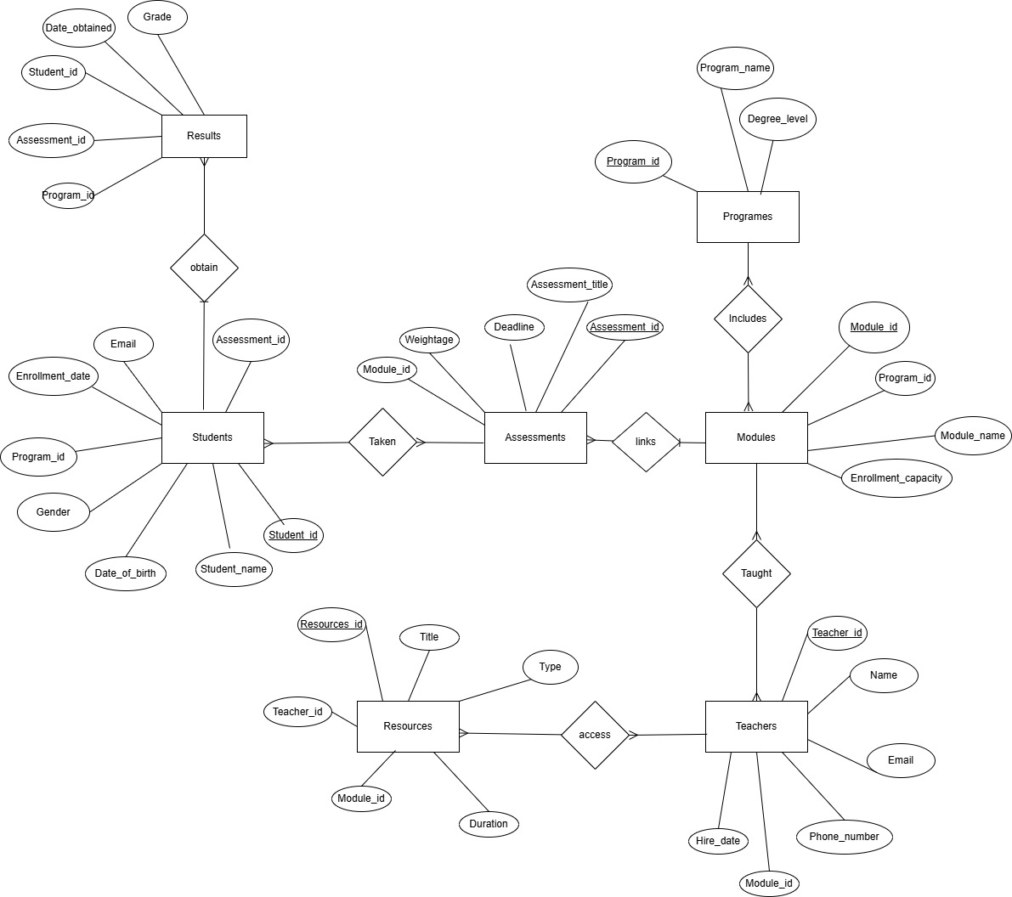
Figure 1:Entities relationships Diagram

3.Normalization
Normalization is the method of structuring data within a database to enhance organization. This involves designing tables and defining relationships between them according to specific principles aimed at safeguarding the data and improving database flexibility by reducing redundancy and inconsistent dependencies. (Qiu1987, et al., 2024)
Normalization from UNF to 3NF

Un-Normalization From (UNF)
Unnormalized Form (UNF), also referred to as an unnormalized relation or a non-first normal form (NF2) relation, is a basic method of representing data in a data model. It is the simplest structure for organizing tables in a database and does not adhere to any normalization principles. UNF is marked by redundant data and frequently includes complex data structures within a single attribute. (Garge, 2024)
- Programs (Program_id, Program_name, Degree_level, Student_id, Student_name, Student_DOB, Gender, Student_enrollment_date, Student_email, {Program_id, Module_id, Module_name, Module_enrollment_capacity, Teacher_id, Teacher_name, Teacher_email, Phone_number, Hire_date, Assessment_id, Assessment_title, Deadline, Weightage, Resources_id, Resources_title, Resources_type, Resources_duration, Grade, Date_obtained ,Status})

1st Normal Form (1NF)

- Programs (Program_id, Program_name, Degree_level, Student_id, Student_name, Student_DOB, Gender, Student_enrollment_date, Student_email)

- Module_enrollment (Program_id, Module_id, Module_name, Module_enrollment_capacity, Teacher_id, Teacher_name, Teacher_email, Phone_number, Hire_date, Assessment_id, Assessment_title, Deadline, Weightage, Resources_id, Resources_title, Resources_type, Resources_duration, Grade, Date_obtained)

2nd Normal Form (2NF)

- Programs (Program_id, Program_name, Degree_level, Student_id, Student_name, Student_DOB, Gender, Student_enrolment_date, Student_email, Grade)

- For Module_enrollment (Program_id, Module_id, Program_id, Module_id, Module_name, Module_enrollment_capacity, Teacher_id, Teacher_name, Teacher_email, Phone_number, Hire_date, Assessment_id, Assessment_title, Deadline, Weightage, Resources_id, Resources_title, Resources_type, Resources_duration, Grade, Date_obtained)

- Program_id->
- Module_id-> Module_details
Modules (Program_id, Module_id, Module_name, Module_enrollment_capacity, Assessment_id, Assessment_title, Deadline, Weightage)

- Teacher_id->Teacher_details
Teachers (Module_id, Teacher_id, Teacher_name, Teacher_email, Phone_number, Hire_date)

- Program_id, Module_id->
Program_Modules (Program_id, Module_id)

- Teacher_id, Module_id->
Teacher_Module (Module_id, Teacher_id, Resources_id, Resources_title, Resources_type, Resources_duration)
- Result (Student_id, Assessment_id, Program_id, Module_id, Grade, Date_obtained)

3rd Normal Form

- Programs (Program_id, Program_name, Degree_level)

- Students (Student_id, Student_name, Student_DOB, Gender, Student_enrolment_date, Student_email, Assessment_id)

- Program_Students (Program_id, Student_id)

- Modules (Module_id, Module_name, Module_enrollment_capacity)

- Program_Modules (Program_id, Module_id)

- Teachers (Teacher_id, Teacher_name, Teacher_email, Phone_number, Hire_date)

- Teacher_Modules (Module_id, Teacher_id)

- Resources (Resources_id, Resources_title, Resources_type, Resources_duration, Teacher_id, Module_id)

- Teacher_Resources (Teacher_id, Resources_id)

- Assessments (Assessment_id, Assessment_title, Deadline, Weightage, Module_id)

- Student_ assessments (Assessment_id, Student_id)

- Result (Student_id, Assessment_id, Program_id, Module_id, Grade, Date_obtained,)

Therefore, the tables that were obtained after the normalization are:
- Programs
- Students
- Program_Students
- Modules
- Program_Modules
- Teachers
- Teacher_Modules
- Resources
- Teacher_Resources
- Assessments
- Result

4.Final ERD
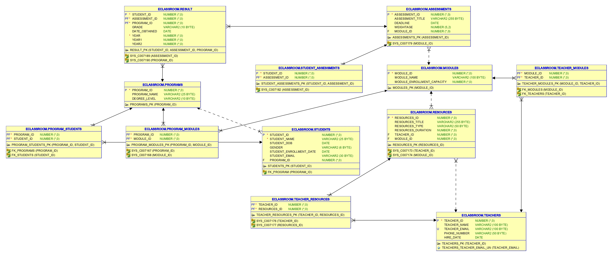
Figure 2:Final ERD

5.Database Implementation
The first step in building our database involves creating a user. Using Oracle SQL and SQL Developer, I developed a database named “Eclassroom”, designed as an online platform. This database is structured to effectively manage programs, student information, modules, teachers, and assessments. It has been configured to comply with business rules and support smooth operations within the Oracle SQL Developer environment.
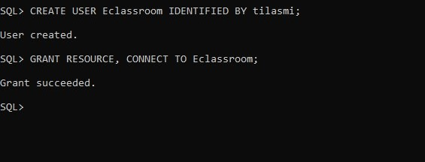
Figure 3: User created
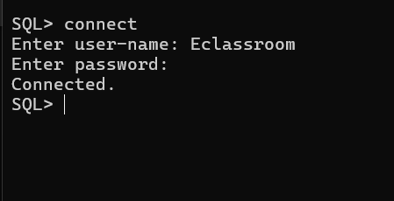
Figure 4: User connected

After creating the user, we proceed to design the database by creating the necessary tables. The list of tables to be created is outlined below:
- Programs
- Students
- Program_students
- Modules
- Program_Modules
- Teachers
- Teacher_Modules
- Resources
- Teacher_Resources
- Assessments
- Result

Table Creation
The tables created in the database, as detailed, as detailed earlier following the normalization process, are as follows:

Creating Programs Table
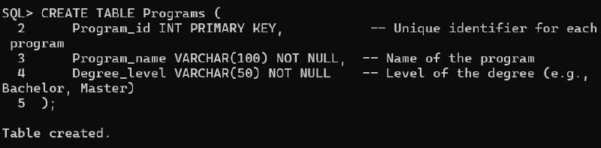
Figure 5:Creating Program Table

Creating Students Table
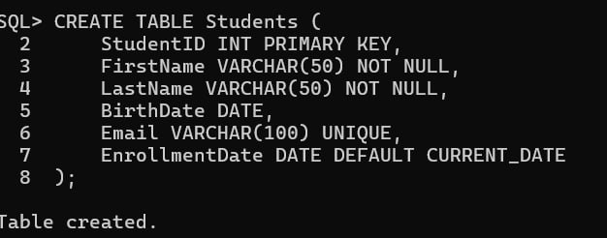
Figure 6:Creating Students Table
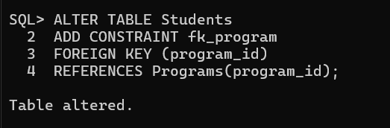
Figure 7: Altered Students table

Creating Program_students Table
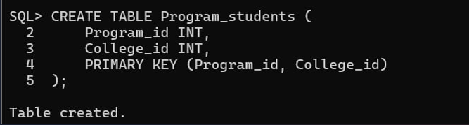
Figure 8:Creating Program_students Table
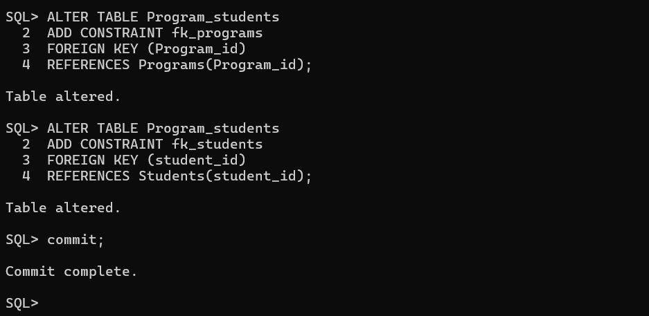
Figure 9:Altering Program_students Table

Creating Modules Table
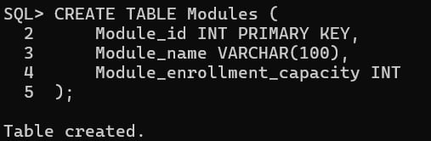
Figure 10:Creating Modules Table
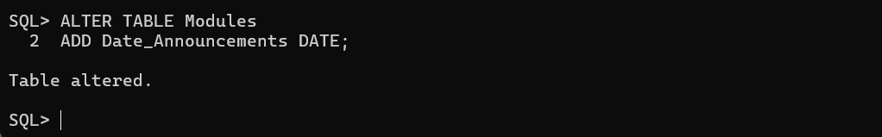
Figure 11: Altered Modules table

Creating Program_Moduels Table
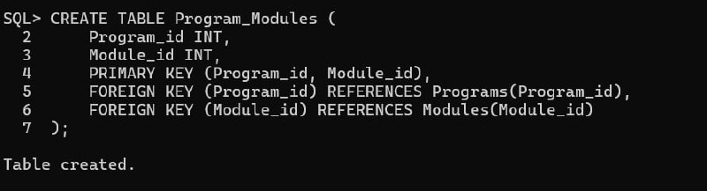
Figure 12:Creating Program_Moduels Table

Creating Teachers Table
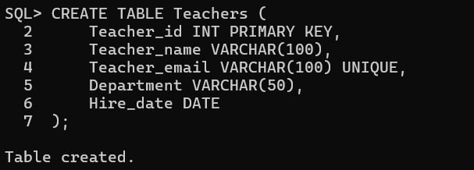
Figure 13:Creating Teachers Table

Creating Teacher_Modules Table
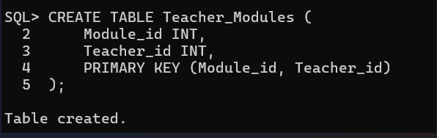
Figure 14:Creating Teacher_Modules Table
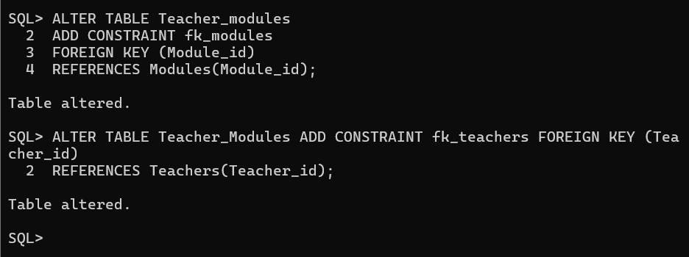
Figure 15: Altering Teacher_Modules

Creating Resources Table
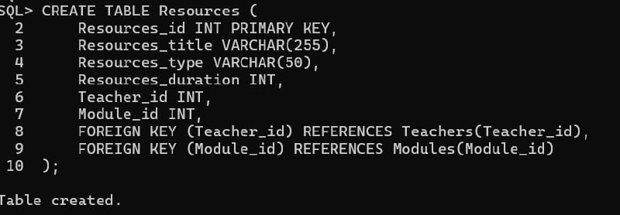
Figure 16:Creating Resources Table

Creating Teacher_Resources Table
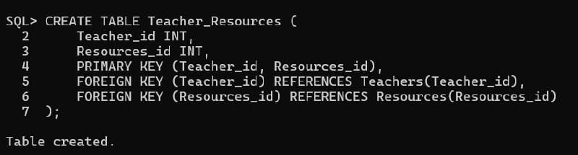
Figure 17:Creating Teacher_Resources Table

Creating Assessments Table
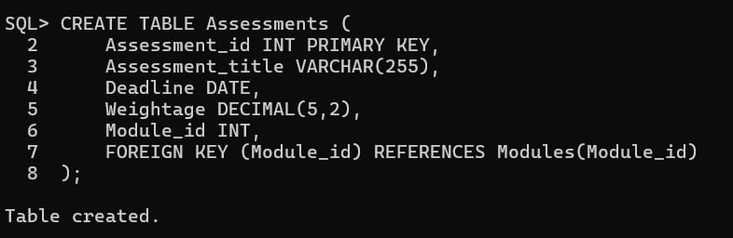
Figure 18:Creating Assessments Table

Creating Student_assessments Table
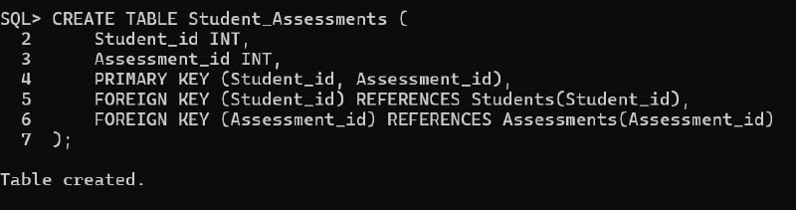
Figure 19:Creating Student_assessments Table

Creating Result Table
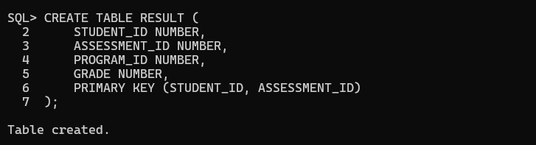
Figure 20:Creating Result Table
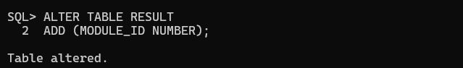
Figure 21: Altering result table

Creating Announcements Table
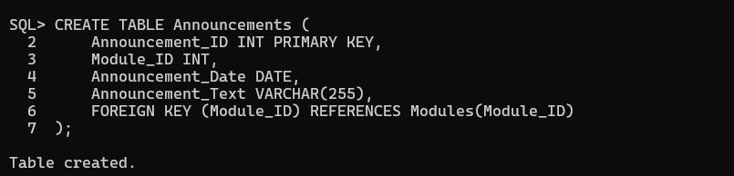
Figure 22: Creating Announcements table

6.Insert Statement
The SQL insert statement plays a crucial role in adding one or more records to a table in a relational database. It enables the efficient insertion of new data while ensuring the database remains complete and maintains its integrity.

Inserting into Programs Table
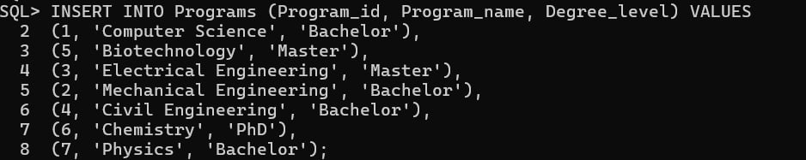
Figure 23:Inserting into Programs Table

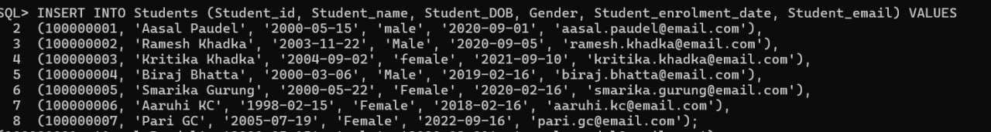
Inserting into Students Table

Figure 24:Inserting into Students Table

Inserting into Program_students Table
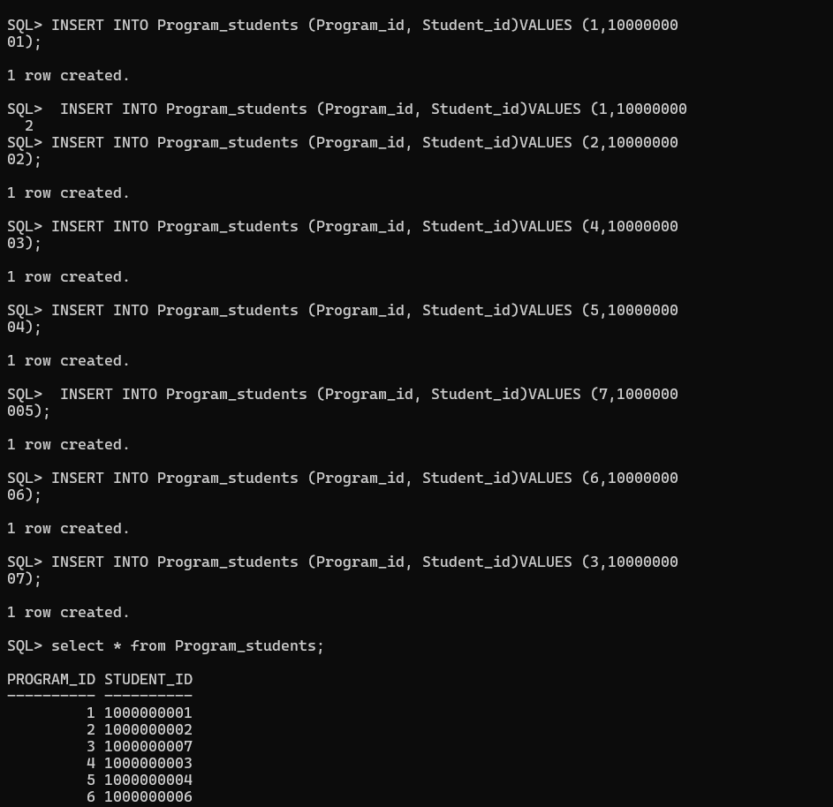
Figure 25:Inserting into Program_students Table

Inserting into Modules Table
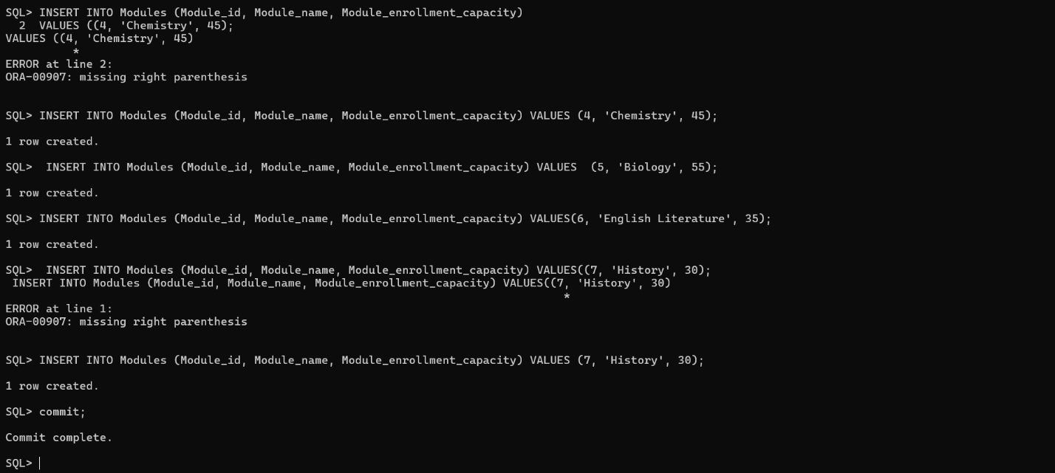
Figure 26:Inserting into Modules Table
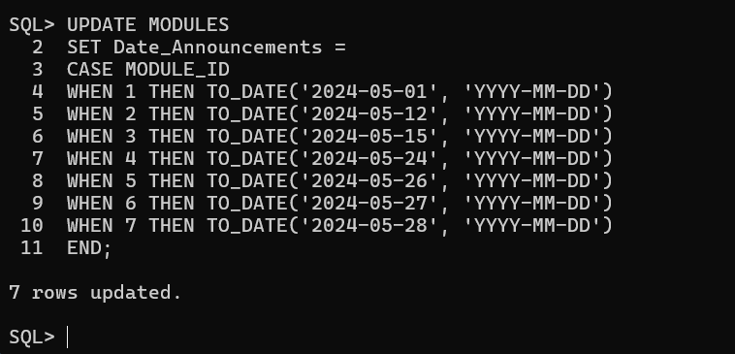
Figure 27: Updating Module’s Date_Announcements row
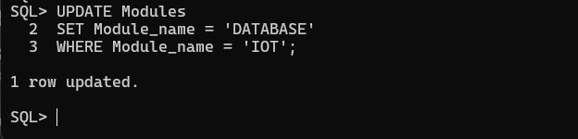
Figure 28: Updating module’s IOT row

Inserting into Program_Moduels Table
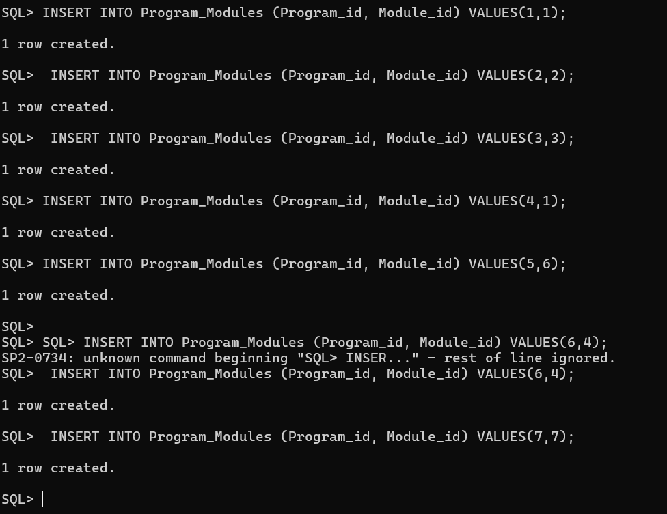
Figure 29:Inserting into Program_Moduels Table

Inserting into Teachers Table
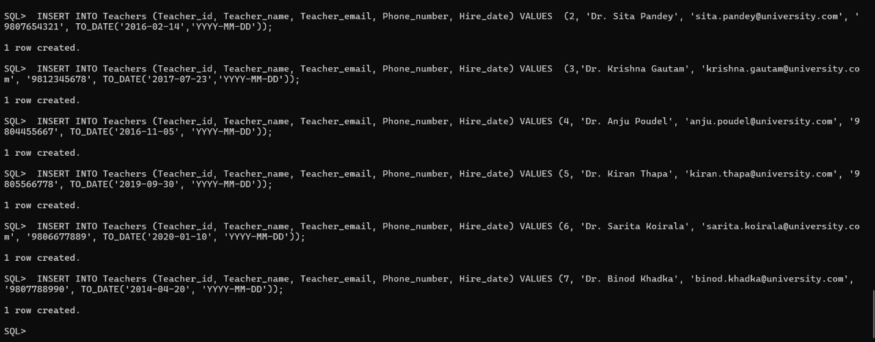
Figure 30:Inserting into Teachers Table

Inserting into Teacher_Modules Table
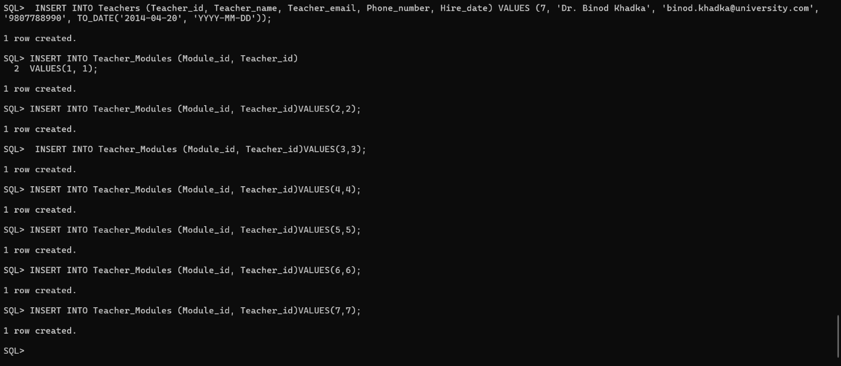
Figure 31:Inserting into Teacher_Modules Table
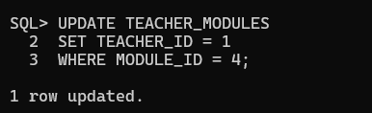
Figure 32: Updating Teacher_Modules table
Figure 33: Updating Teacher_Modules II

Inserting into Resources Table
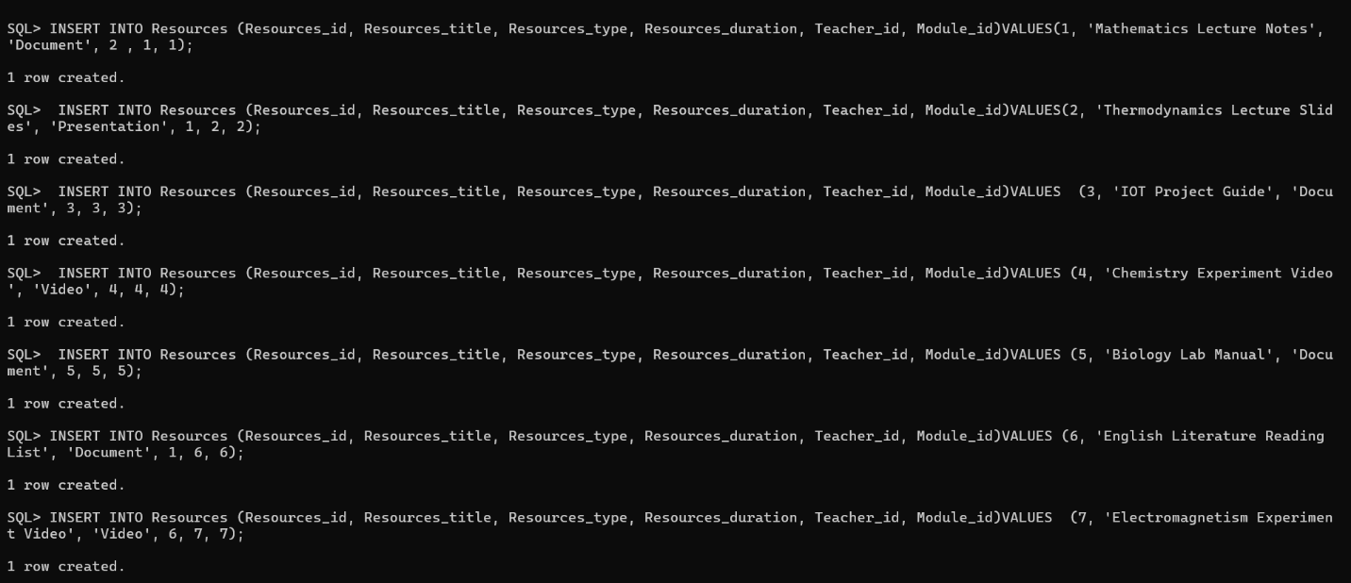
Figure 34:Inserting into Resources Table

Inserting into Teacher_Resources Table
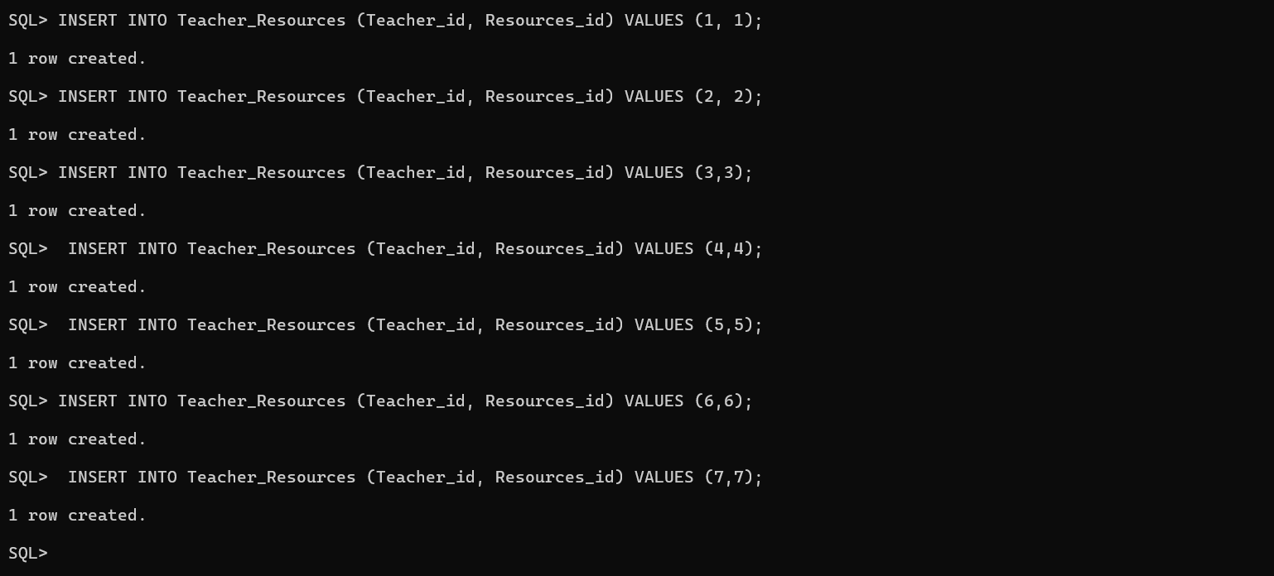
Figure 35:Inserting into Teacher_Resources Table

Inserting into Assessments Table
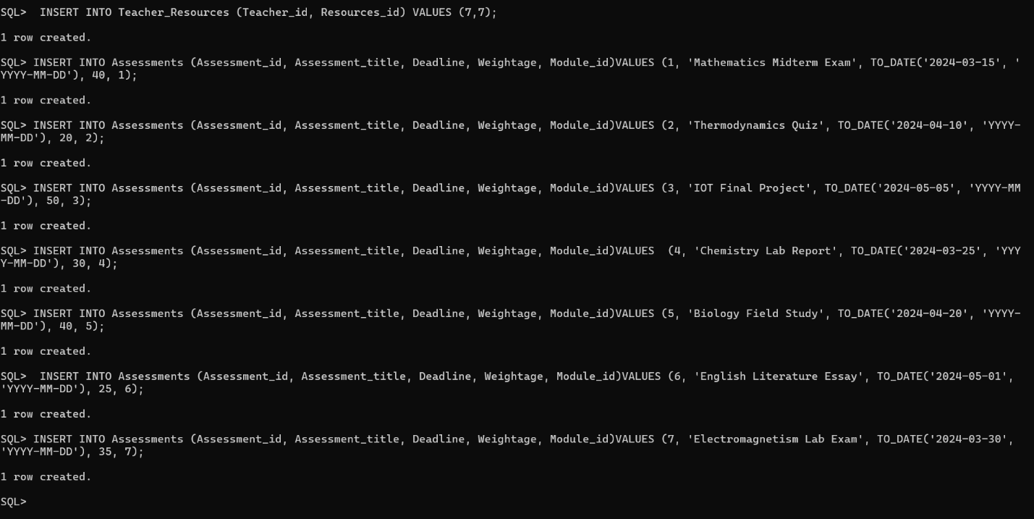
Figure 36:Inserting into Assessments Table

Inserting into Student_assessments Table
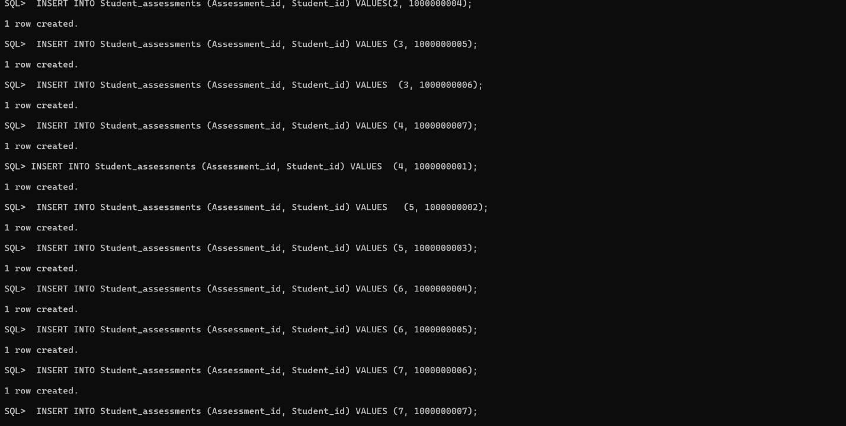
Figure 37:Inserting into Student_assessments Table

Inserting into Result Table

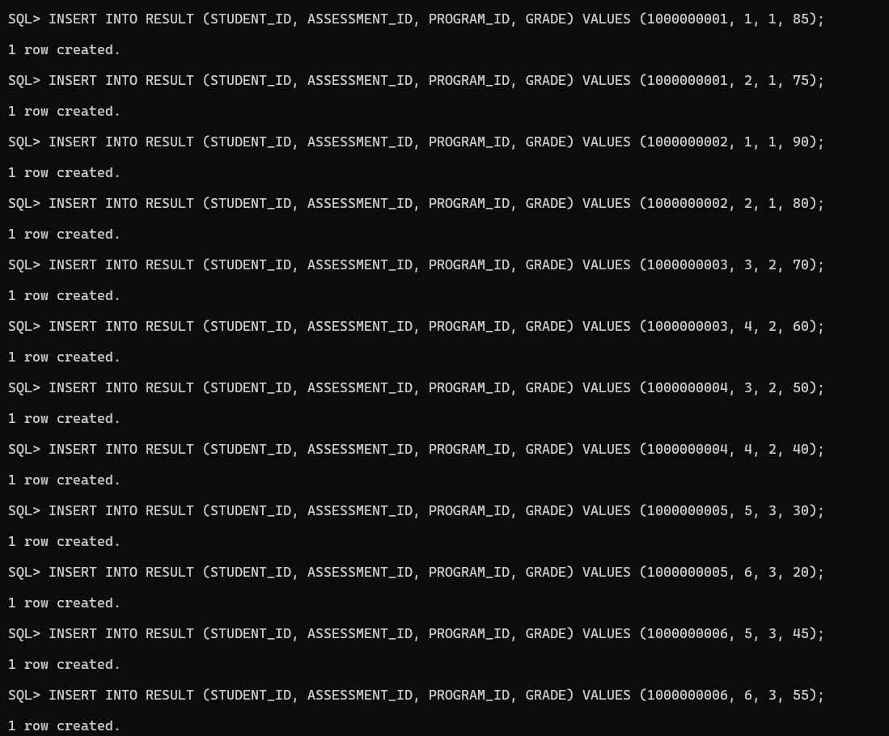
Figure 38:Inserting into Result Table

Inserting into Announcements Table
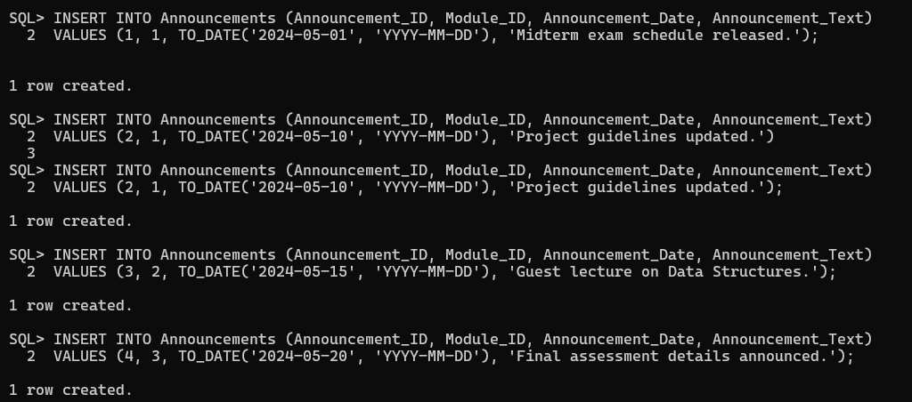
Figure 39: Inserting Announcements table

7.Select Statement

Displaying Programs Table
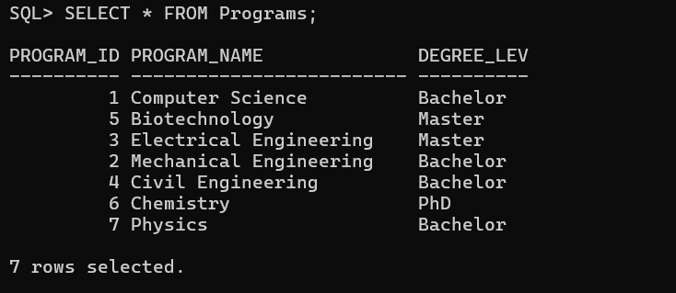
Figure 40:Displaying Programs Table

Displaying Students Table
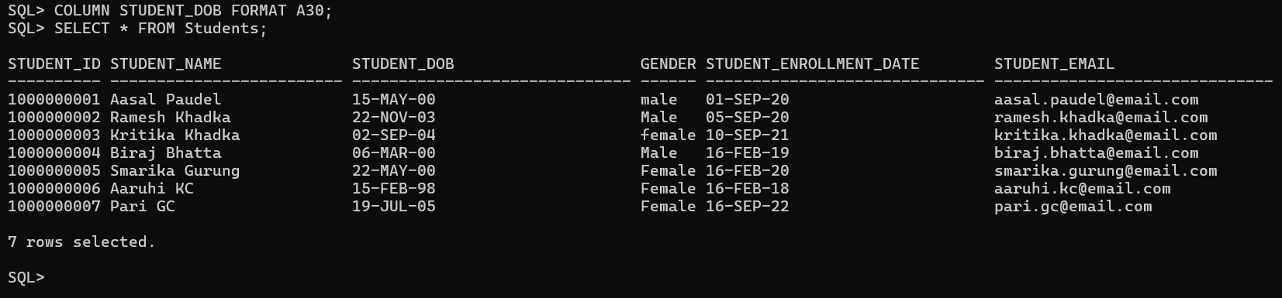
Figure 41:Displaying Students Table

Displaying Program_students Table
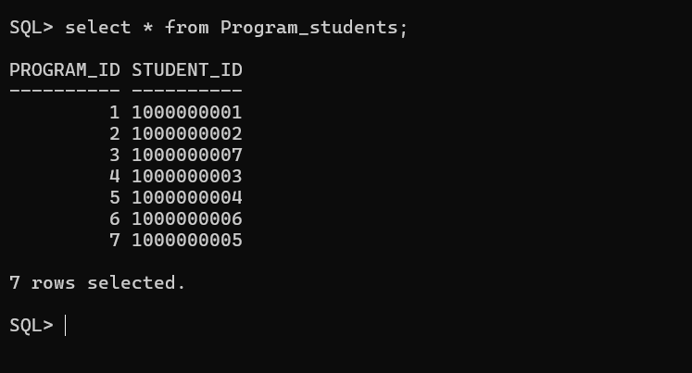
Figure 42:Displaying Program_students Table

Displaying Modules Table
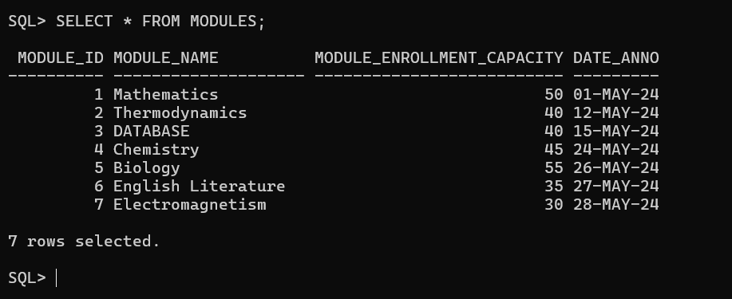
Figure 43:Displaying Modules Table

Displaying Program_Moduels Table
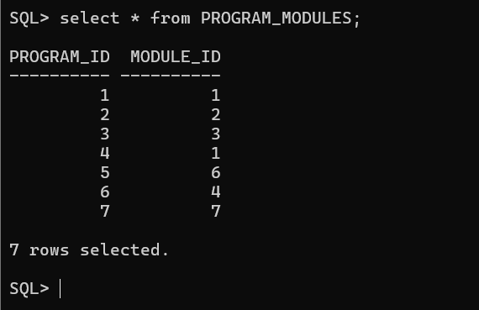
Figure 44:Displaying Program_Moduels Table

Displaying Teachers Table
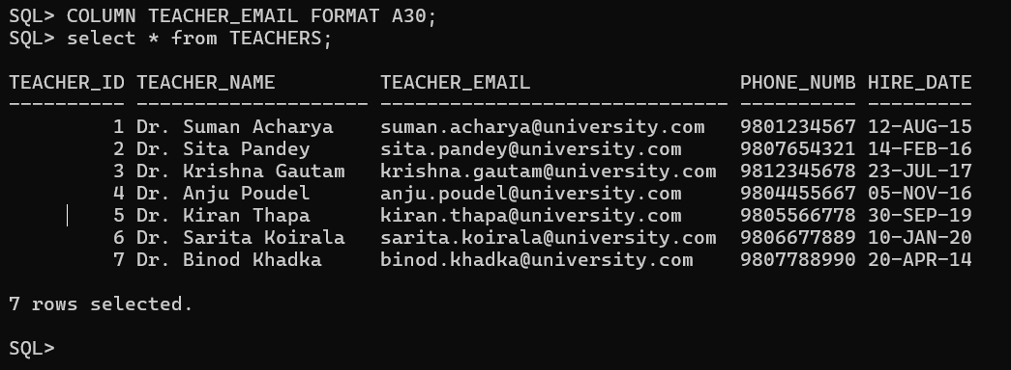
Figure 45:Displaying Teachers Table

Displaying Teacher_Modules Table
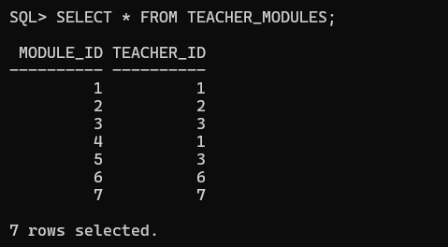
Figure 46:Displaying Teacher_Modules Table

Displaying Resources Table
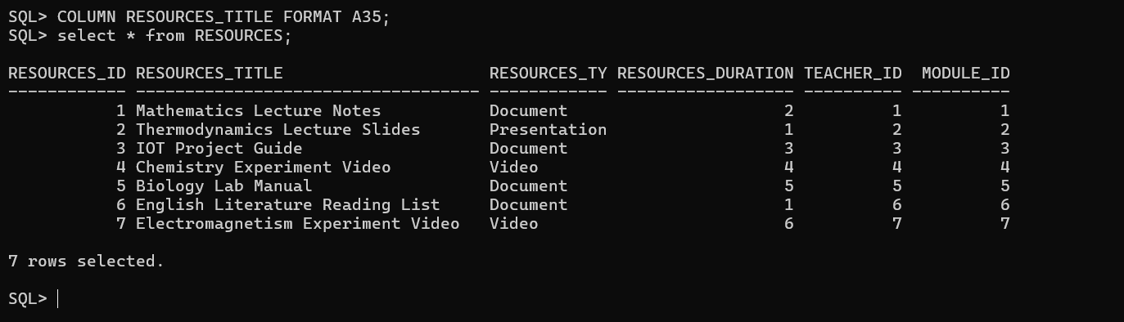
Figure 47:Displaying Resources Table

Displaying Teacher_Resources Table
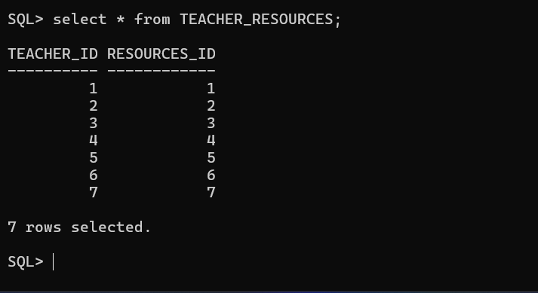
Figure 48:Displaying Teacher_Resources Table

Displaying Assessments Table
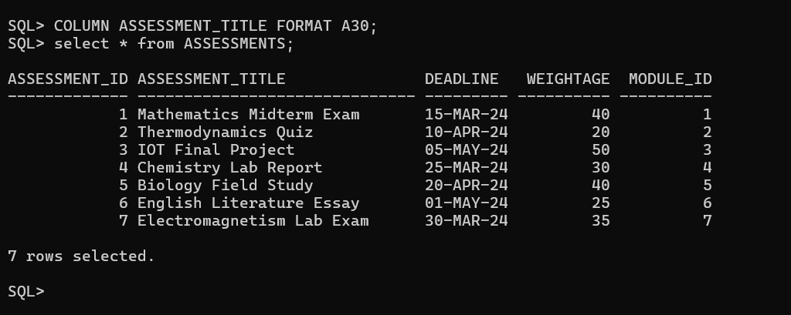
Figure 49:Displaying Assessments Table

Displaying Student_assessments Table
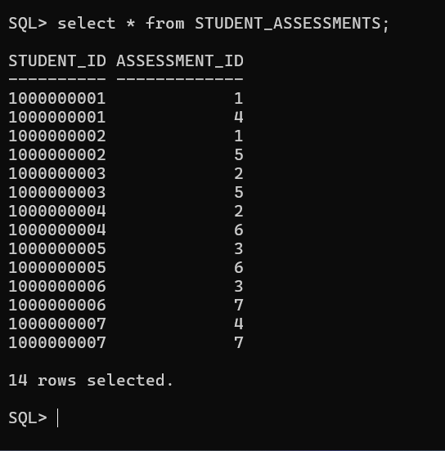
Figure 50:Displaying Students_assessments Table

Displaying Result Table

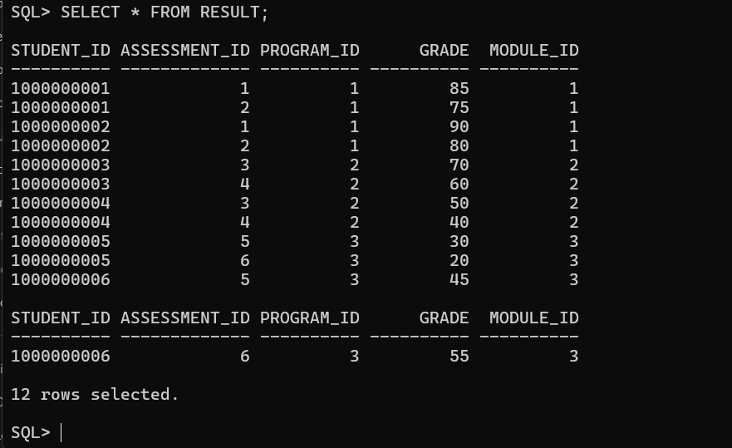
Figure 51:Displaying Result Table

Displaying Announcements Table
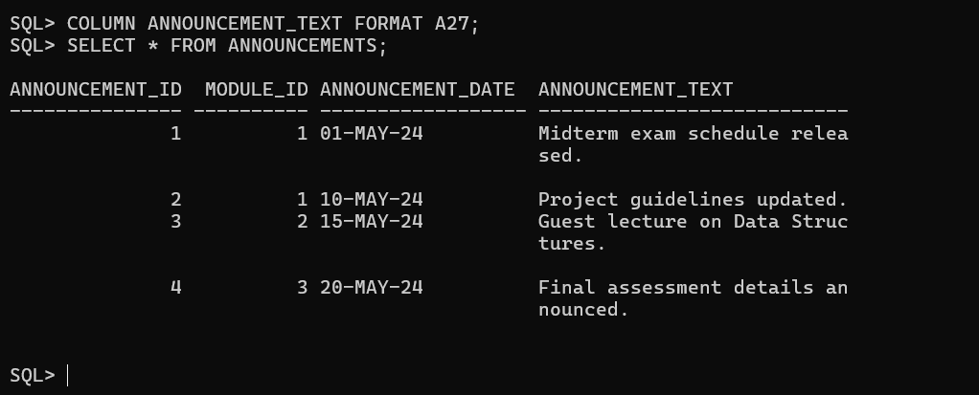
Figure 52: Displaying Announcements table

8.Information and Transaction Query

8.1Information query

- List the programs that are available in the college and the total number of students enrolled in each.
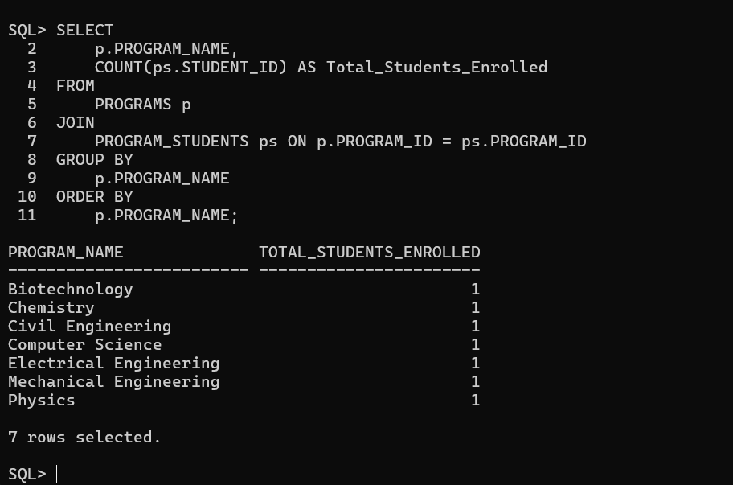
Figure 53: Information query1

- List all the announcements made for a particular module starting from 1st May 2024 to 28th May 2024.

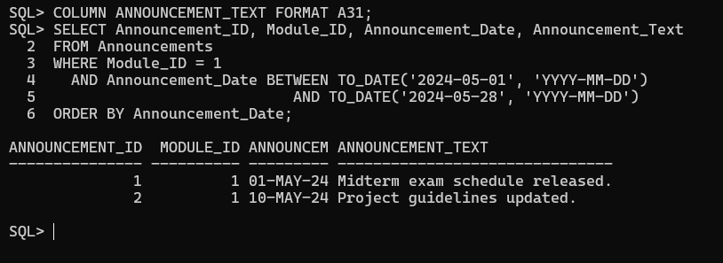
Figure 54: Information query 2

- List the names of all modules that begin with the letter ‘D’, along with the total number of resources uploaded for those modules.
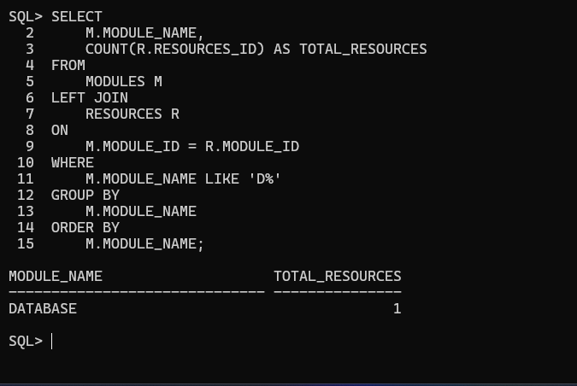
Figure 55: Information query 3
- List the names of all students along with their enrolled who have not submitted any assessments for a particular module.
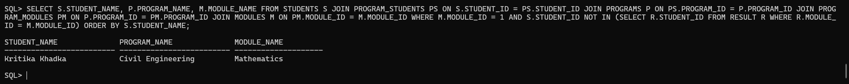
Figure 56: Information query 4

- List all the teachers who teach more than one module.
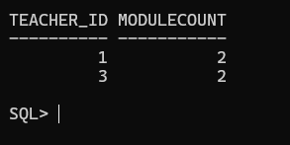
Figure 57: Information query 5

8.2. Transaction query

- Identify the module that has the latest assessment deadline.
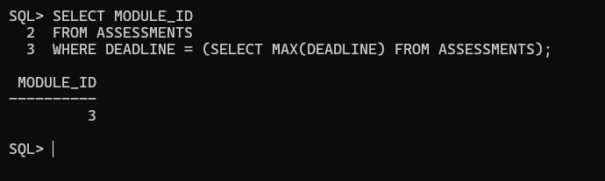
Figure 58: Transaction query 1

- Find the top three students who have the highest total score across all modules.

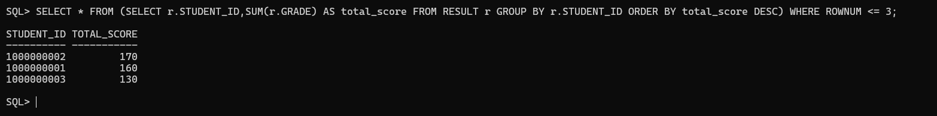
Figure 59: Transaction query 2
- Find the total number of assignments for each program and the average score across all assessments in those programs.

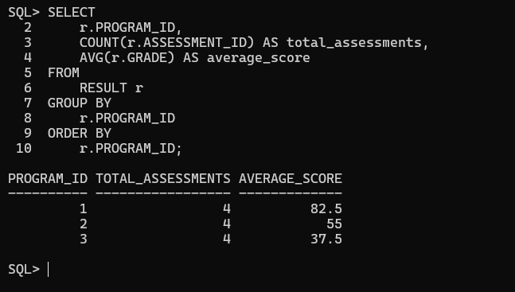
Figure 60: Transaction query 3

- List the students who have scored above the average score in ‘Databases’ module.

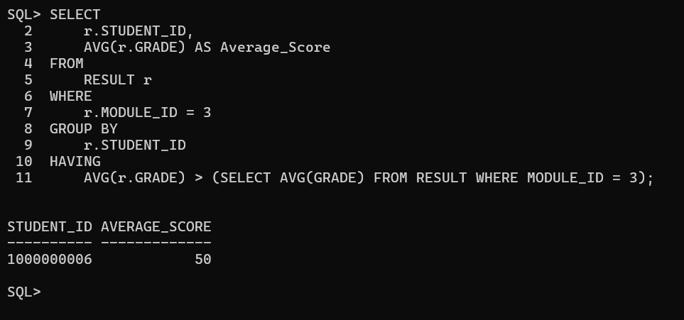
Figure 61: Transaction query 4

- Display whether a student has passed or failed as remarks as per their total aggregate marks obtained in a particular module. (NOTE: Consider total aggregate marks equal to or above 40 is pass, below 40 is fail)

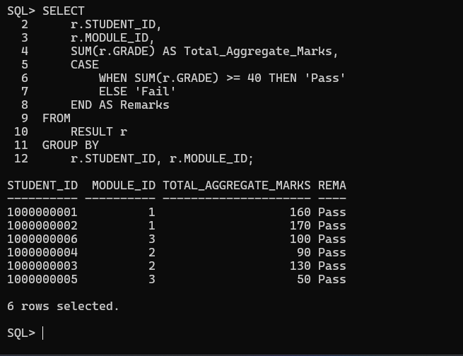
Figure 62: Transaction query5

9.Creating Dump file and Drop Table

Dump File:
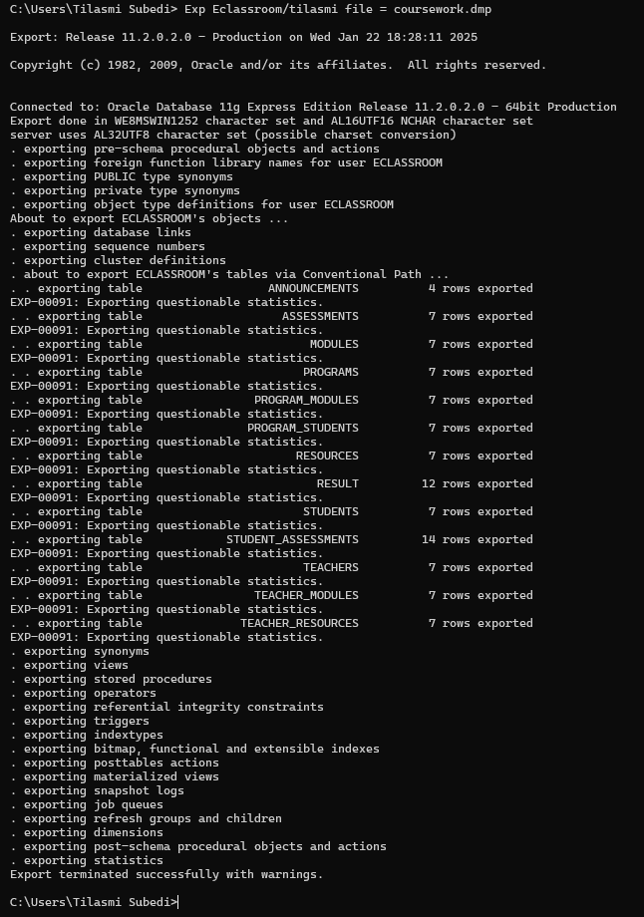
Figure 63: Dump file creation
DROP TABLE:
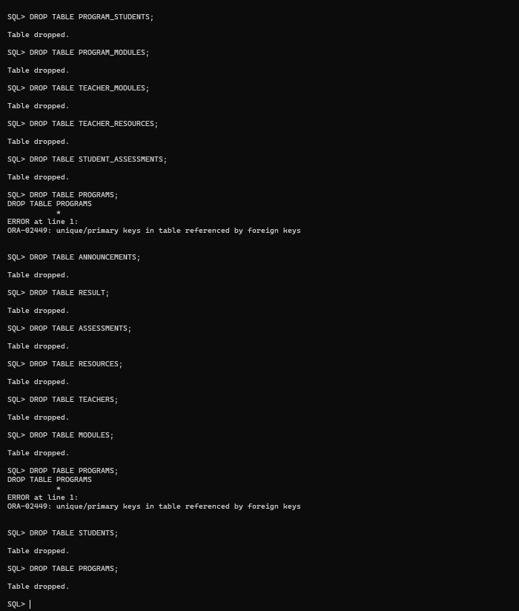
Figure 64: Dropping all the tables

10.Data Dictionary

Programs Table
Table 3:Programs data dictionary
Attribute | Data Type | Description | Length | Key | Null | Unique
Program_id | INT | Unique identifier for each program. | 10 | Primary | NO | YES
Program_name | VARCHAR | Name of program. | 25 |  | NO | NO
Degree_level | VARCHAR | Level of the degree (e.g., Bachelor’s, Master’s). | 25 |  | NO | NO

Students Table
Table 4:Students data dictionary
Attribute | Data Type | Description | Length | Key | Null
Student_id | INT | Unique identifier for each student. | 10 | Primary | NO
Student_name | VARCHAR | Full name of the student. | 25 |  | NO
Student_DOB | DATE | Date of the birth of the student. |  |  | NO
Gender | VARCHAR | Gender of the student | 10 |  | NO
Student_Enrollment_Date | DATE | Date the student enrolled. |  |  | NO
Student_email | VARCHAR | Email address of the student. | 30 |  | NO

Program_students Table
Table 5:Program_students data dictionary
Field Name | Data Type | Description | Length | Key | Null | Unique
Program_id | INT | Composite primary key referencing Programs. | 10 | Foreign | NO | NO
Student_id | INT | Composite primary referencing Students. | 10 | Foreign | NO | NO

Modules Table
Table 6:Modules data dictionary
Attribute | Data Type | Description | Length | Key | Null | Unique
Module_id | INT | Unique identifier for each module. | 10 | Primary | NO | YES
Module_name | VARCHAR | Name of the module. | 20 |  | NO | NO
Module_Enrollment  _Capacity | INT | Maximum number of students per module. | 26 |  | NO | NO
Date_Announcement | DATE | Date of announcement. | 10 |  | NO | NO

Program_Modules Table
Table 7:Program_Modules data dictionary
Attribute | Data Type | Description | Length | Key | Null | Unique
Program_id | INT | Composite primary key referencing Programs. | 10 | Foreign | NO | NO
Module_id | INT | Composite primary key referencing Modules. | 10 | Foreign | NO | NO

Teacher Table
Table 8: Teacher data dictionary
Attribute | Data Type | Description | Length | Key | Null | Unique
Teacher_id | INT | Unique identifier for each teacher. | 10 | Primary | NO | YES
Teacher_name | VARCHAR | Full name of the teacher. | 25 |  | NO | NO
Teacher_email | VARCHAR | Email address of the teacher. | 30 |  | NO | YES
Phone_number | VARCHAR | Phone number of the teacher. | 15 |  | NO | NO
Hire_date | DATE | Date the teacher was hired. |  |  | NO | NO

Teacher_Modules Table
Table 9:Teacher_Modules data dictionary
Attribute | Data Type | Description | Length | Key | Null | Unique
Module_id | INT | Composite primary key referencing Modules. | 10 | Foreign | NO | YES
Teacher_id | INT | Composite primary key referencing Teachers. | 10 | Foreign | NO | YES

Resources Table
Table 10:Resources data dictionary
Field Name | Data Type | Description | Length | Key | Null | Unique
Resources_id | INT | Unique identifier for each resource. | 10 | Primary | NO | YES
Resources_title | VARCHAR | Title of the resource. | 25 |  | NO | NO
Resources_type | VARCHAR | Type of resource (e.g., video. Book). | 12 |  | NO | NO
Resources_duration | INT | Duration of the resource | 10 |  | NO | NO
Teacher_id | INT | Foreign key referencing Teachers. |  | Foreign | NO | YES
Module_id | INT | Foreign key referencing modules. |  | Foreign | NO | YES

Teacher_Resources Table
Table 11:Teacher_Resources data dictionary
Field Name | Data Type | Description | Length | Key | Null | Unique
Teacher_id | INT | Composite primary key referencing Teachers. | 10 | Foreign | NO | YES
Resources_id | INT | Composite primary key referencing Resources. | 10 | Foreign | NO | YES

Assessments Table
Table 12:Assessments data dictionary
Attribute | Data Type | Description | Length | Key | Null | Unique
Assessment_id | INT | Unique identifier for each assessment. | 10 | Primary | NO | YES
Assessment_title | VARCHAR | Title of the assessment. | 10 |  | NO | NO
Deadline | DATE | Due date for the assessment. |  |  | NO | NO
Weightage | DECIMAL | Percentage weight of the assessment. | 10 |  | NO | NO
Module_id | INT | Foreign key referencing Modules. | 10 | Foreign | NO | YES

Students_Assessments Table
Table 13:Students_Assessments data dictionary
Attribute | Data Type | Description | Length | Key | Null | Unique
Assessment_id | INT | Composite primary key referencing Assessments. | 10 | Foreign | NO | YES
Student_id | INT | Composite primary key referencing Students. | 10 | Foreign | NO | YES

Result Table
Table 14:Result data dictionary
Attribute | Data Type | Description | Length | Key | Null | Unique
Student_id | INT | Foreign key referencing Students. | 10 | Foreign | NO | YES
Assessment_id | INT | Foreign key referencing Assessments. | 10 | Foreign | NO | YES
Program_id | INT | Foreign key referencing Programs. | 10 | Foreign | NO | YES
Grade | INT | Grade obtained by the student. | 10 |  | NO | NO
Module_id | INT | Foreign key referencing Modules. | 10 | Foreign | NO | YES

Announcements Table
Table 15:Announcements table
Attribute | Data Type | Description | Length | Key | Null | Unique
Announcement_id | INT | Unique identifier for each announcement. | 10 | Primary | NO | YES
Module_id | INT | Foreign key referencing Modules. | 10 | Foreign | NO | YES
Announcement_text | VARCHAR | Date on which the announcement was made. | 27 |  | NO | NO
Date_Announcement | DATE | Date of announcement. | 10 |  | NO | NO

9.Conclusion

This coursework has been an insightful and enriching journey, offering a hands-on opportunity to apply database design principles to a practical scenario. The project revolves around creating a robust database system for the “E-Classroom” platform, designed to streamline the management of students, teachers, programs, modules, and assessments. By working on this case study, a deeper understanding of the real-world applications of database systems has been achieved.
The process included designing and refining Entity Relationship Diagrams (ERDs), normalizing data into Third Normal Form (3NF), and writing efficient SQL queries to support the platform’s functionality. Challenges, such as maintaining data integrity and ensuring efficient query execution, were navigated successfully, fostering problem-solving skill and technical expertise.
The case study highlighted the importance of structured data management in educational platforms, enabling features like tracking student progress, managing module resources, and ensuring a logical sequence of resource completion. This practical context underscored the significance of database systems in creating a dynamic and efficient digital environment.
Beyond fulfilling the coursework objectives, this experience has been instrumental in strengthening technical and analytical skills while demonstrating the broader impact of database systems in addressing complex organizational needs. The knowledge and expertise gained from this project provide a strong foundation for future academic pursuits and professional endeavours in database design and management.

9.References
Garge, S., 2024. Alchetron. [Online]
Available at: https://alchetron.com/Unnormalized-form
[Accessed 09 October 2024].
h. et al., 2024. Microsoft Learn Challenge. [Online]
Available at: https://learn.microsoft.com/en-us/office/troubleshoot/access/database-normalization-description
[Accessed 23 November 2024].
Melanie, 2024. DataScientest. [Online]
Available at: https://datascientest.com/en/primary-key-definition-advantages-and-special-features
[Accessed 23 April 2024].
Oyairo, A., 2024. builtin. [Online]
Available at: https://builtin.com/articles/entity-relationship-diagram
[Accessed 3 June 2024].
S, R. A., 2024. simplilearn. [Online]
Available at: https://www.simplilearn.com/tutorials/sql-tutorial/er-diagram-in-dbms
[Accessed 2 December 2024].

